React

Create a React Application “eventexamplesapp” to handle various events of the form elements in HTML.

1. Create “Increment” button to increase the value of the counter and “Decrement” button to decrease the value of the counter. The “Increase” button should invoke multiple methods.
   1. To increment the value
   2. Say Hello followed by a static message.

import React, { useState } from 'react';

import './App.css';

import CurrencyConverter from './CurrencyConverter';

function App() {

  const [counter, setCounter] = useState(0);

  const increment = () => {

    setCounter(prev => prev + 1);

    sayHello();

  };

  const decrement = () => {

    setCounter(prev => prev - 1);

  };

  const sayHello = () => {

    console.log("Hello! You clicked the increment button.");

  };

  const sayWelcome = (msg) => {

    alert(msg);

  };

  const handleClick = () => {

    alert("I was clicked");

  };

  return (

    <div className="App">

      <h1>Event Examples App</h1>

      <h2>Counter: {counter}</h2>

      <button onClick={increment}>Increment</button>

      <button onClick={decrement}>Decrement</button>

      <br /><br />

      <button onClick={() => sayWelcome("Welcome friends!")}>Say Welcome</button>

      <br /><br />

      <button onClick={handleClick}>Click here</button>

      <br /><br />

      <CurrencyConverter />

    </div>

  );

}

export default App;

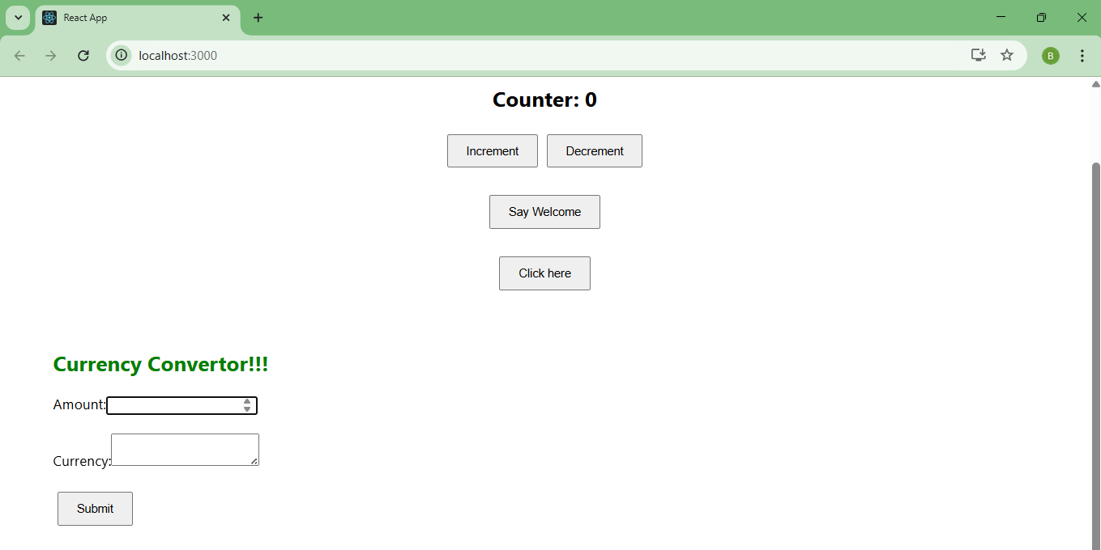

1. Create a button “Say Welcome” which invokes the function which takes “welcome” as an argument.

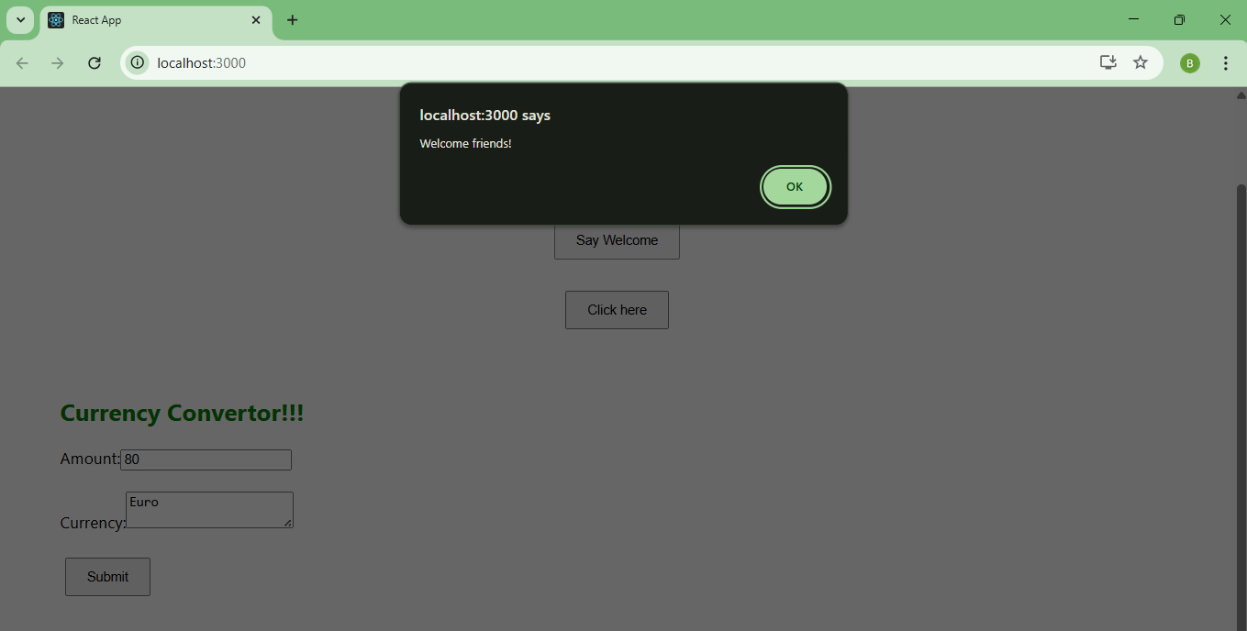

1. Create a button which invokes synthetic event “OnPress” which display “I was clicked”.

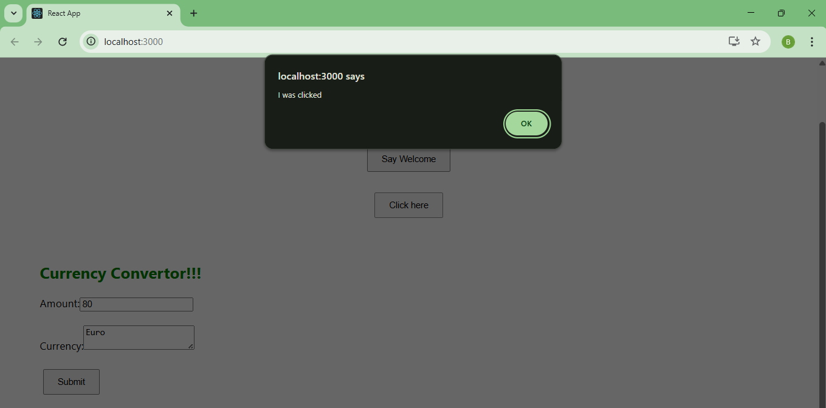

1. Create a “CurrencyConvertor” component which will convert the Indian Rupees to Euro when the Convert button is clicked.

Handle the Click event of the button to invoke the handleSubmit event and handle the conversion of the euro to rupees.

import React, { useState } from 'react';

function CurrencyConverter() {

  const [amount, setAmount] = useState('');

  const [converted, setConverted] = useState('');

  const [currency, setCurrency] = useState('');

  const handleSubmit = () => {

    if (currency.toLowerCase() === 'euro') {

      const result = parseFloat(amount) \* 80; // ₹1 = €0.0125 ⇒ €1 ≈ ₹80

      alert(`Converting to Euro Amount is ${result}`);

      setConverted(result);

    } else {

      alert('Please enter "Euro" as currency.');

    }

  };

  return (

    <div style={{ textAlign: 'left', margin: '40px' }}>

      <h2 style={{ color: 'green' }}>Currency Convertor!!!</h2>

      <label>Amount:</label>

      <input

        type="number"

        value={amount}

        onChange={(e) => setAmount(e.target.value)}

      /><br /><br />

      <label>Currency:</label>

      <textarea

        value={currency}

        onChange={(e) => setCurrency(e.target.value)}

      /><br /><br />

      <button onClick={handleSubmit}>Submit</button>

    </div>

  );

}

export default CurrencyConverter;

